**Assignment 1**

**Advance machine learning**

**Step 1: Import Libraries**

* For this task, below are the required libraries to accomplish and each library has it own importance.

* numpy is an linear algebra library which is useful for handling vectors which we are sending our input as vector format.
* Matplotlib is for visualization, to plot our results.
* sklearn is an machine learning libraries to train our model, also we have some methods use for train_test_split and to compute metrics

**Do a 80-20 split of the data**

**Step 2**: Considering Sample data using make_blobs and divided the samples according to the given requirement that is 80 percent train size and 20 per test size.

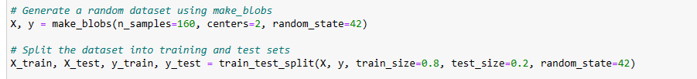

**Perform a KNN analysis of the simulated data**

**Step3:**

Simulated the KNN model using the above dataset requirements.

Initially we need to take k_values ranging from (1,20) to check our results. When we don’t give any k range by default 1 is considered.

Later fit the data using the knn.fit which me we are preparing our model for training.

In the last step we use print statement to display our outputs.

With some parameters, we algorithm as auto and, leaf_size=30 and metric= minkowski and weights=uniform and using 5 n_neighbours.

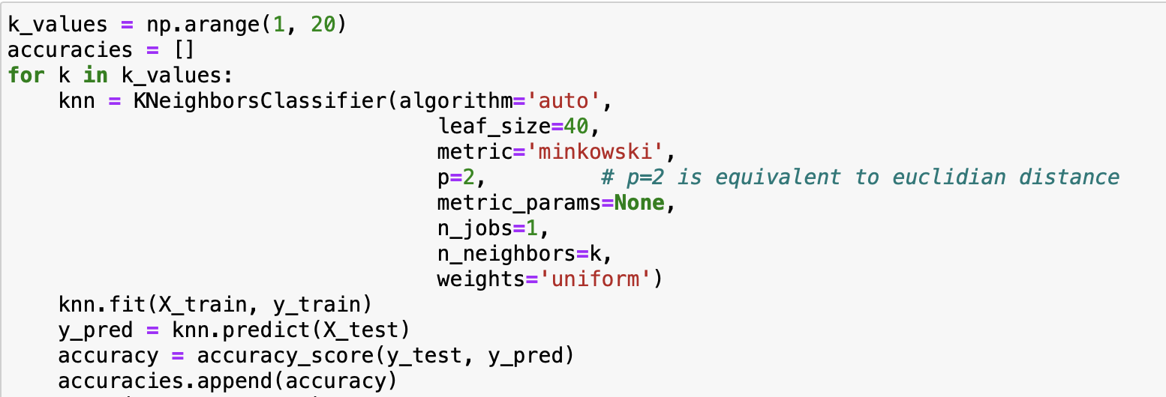

**Output accuracy score**

**Step 4: Results:**

Printing and plotting the results for each k-value, we print predictions from the classifier and target values and test_knn.

**The test accuracy using the above samples is 1 for all the k-values.**

**Also plotted the graph for the same.**

**Plot your different results**

